COMP353_ASSIGNMENT1

YIFAN YANG

40038814

1.1ER diagram

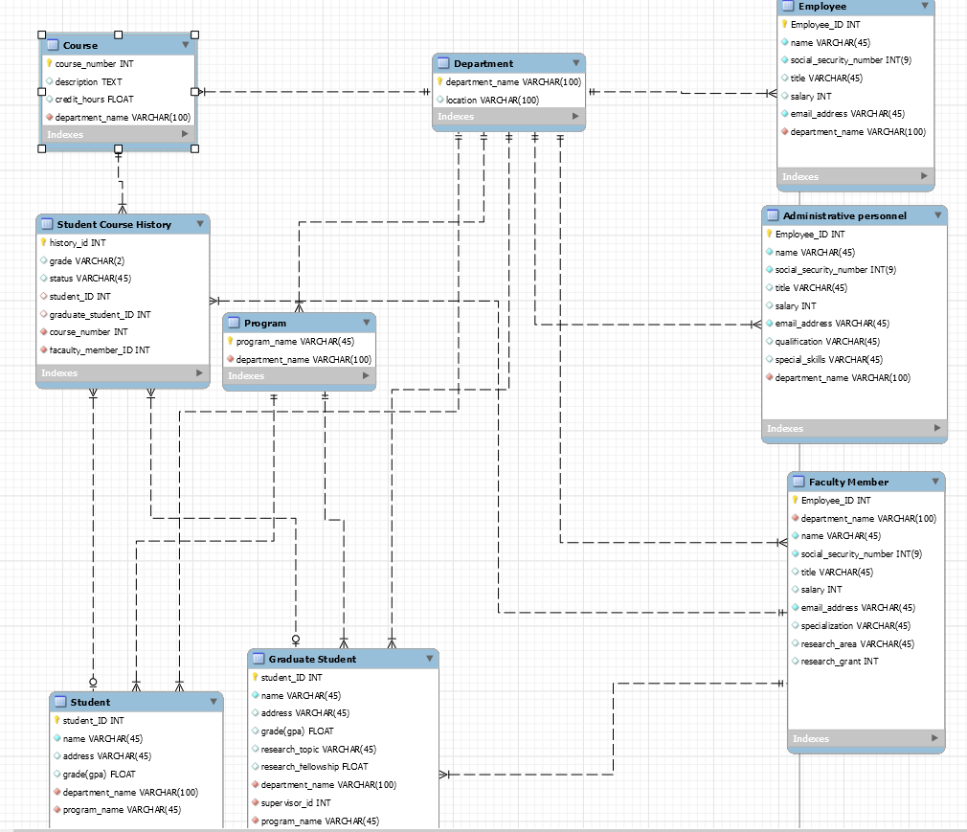

1.2 comment and constraint

 is primary key

 is foreign key

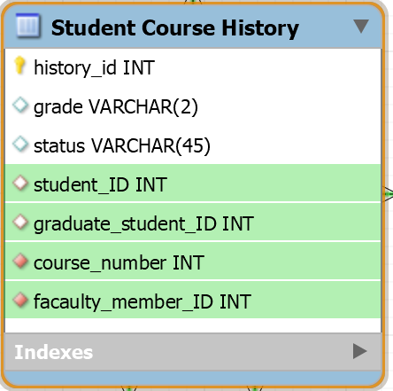The facaulty_member_ID is the professor ID in course history, which points to employee_id in Facaulty Number table

**This table holds all history information for all people, so history_id is auto increment, student should search their history by student_ID**

The database generated by this ER diagram is not enough!!! (er_diagram_40038814.mwb)

because student_ID is for undergraduate student, graduate_student_ID points to graduate student, however, **one of them must be not null**

**so you should use the script below**

alter table `comp353_assignment1`.`Student Course History`

ADD CONSTRAINT check ( (student_ID is null and graduate_student_ID is not null)

or (graduate_student_ID is not null and student_ID is null)

)

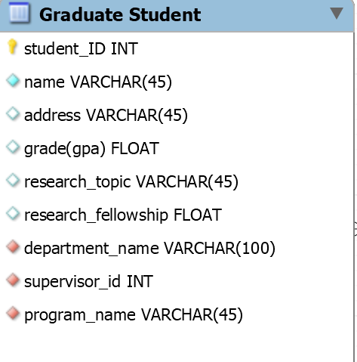 The supervisor_id points to employee_id in Facaulty Number table,which means the graduate student supervised by professor

I'm not sure whether an employee is allowed to work in several departments, so if there is such need, you can just turn 1-n to m-n like this

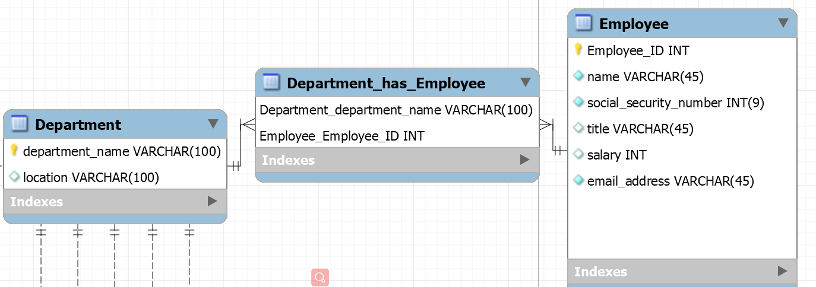

inharitance problem, ISA is not supported in ER diagram like this, so I present every entity in complete form

1.3

First use script ‘university_generation_40038814.sql’

Then use the script below

alter table `comp353_assignment1`.`Student Course History`

ADD CONSTRAINT check ( (student_ID is null and graduate_student_ID is not null)

or (graduate_student_ID is not null and student_ID is null)

)

2

Before using hospital_generation_40038814.sql, please drop original schema ,cause both of the schema has name 'comp353_assignment1'

2.1

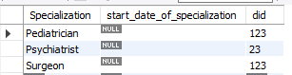

Sol:

SELECT doctor.*

FROM doctor

JOIN specialization on doctor.did=specialization.did

GROUP BY specialization.did

HAVING count(*)>=2



2.2

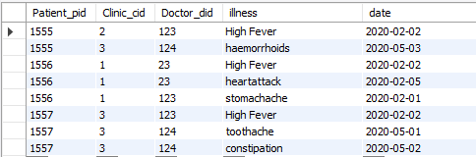

Sol:

SELECT patient_pid,illness,date

FROM consult

WHERE patient_pid=1556 AND (consult.date between '2020-02-02' AND '2020-02-06')

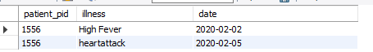

2.3



Sol:

SELECT patient.pname,doctor.dname,clinic.cid,consult.date,clinic.city

FROM consult

JOIN doctor ON consult.Doctor_did=doctor.did

JOIN clinic ON consult.Clinic_cid=clinic.cid

JOIN patient ON consult.Patient_pid=patient.pid

WHERE (clinic.city='montreal' or clinic.city='laval') and (consult.date BETWEEN '2020-01-01' AND '2020-03-15') AND consult.illness='High Fever'



2.4

Consult:



Doctor:



Sol:

SELECT p.*,d.dname,Count(*) as consult_time

FROM consult c

JOIN doctor d on c. Doctor_did=d.did

JOIN patient p on p.pid=c.Patient_pid

WHERE d.dname='Roberto'

GROUP BY Patient_pid

HAVING count(*)>=2



2.5.

The table below is the join of works_in, doctor,clinic

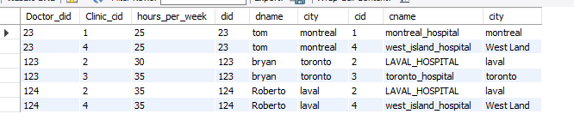

Sol:

SELECT doctor.did,doctor.dname,clinic.city

FROM works_in

JOIN doctor on doctor.did=works_in.Doctor_did

JOIN clinic on clinic.cid=works_in.Clinic_cid

WHERE doctor.did not in (

SELECT doctor.did

FROM works_in

JOIN doctor on doctor.did=works_in.Doctor_did

JOIN clinic on clinic.cid=works_in.Clinic_cid

WHERE clinic.city='West Land'

)

and doctor.did in (

SELECT doctor.did

FROM works_in

JOIN doctor on doctor.did=works_in.Doctor_did

JOIN clinic on clinic.cid=works_in.Clinic_cid

where clinic.city='laval'

)

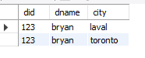

2.6

work_in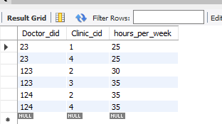

Sol:

SELECT doctor.dname,doctor.city,SUM(works_in.hours_per_week) as 'total'

FROM works_in

JOIN doctor on doctor.did=works_in.Doctor_did

GROUP BY Doctor_did

HAVING total>=60

